UID EXPERIMENT-3b
NAME: M.K.Raghavan ROLL NO.:240701408
AIM:
To create a prototype with both familiar and unfamiliar navigation elements and evaluate ease of use using Wireflow.
OBJECTIVE:
- To design a mobile app prototype using wireflow.
- To include both standard (familiar) and new (unfamiliar) navigation styles.
- To analyze user interaction and usability.
TOOLS USED:
- Wireflow
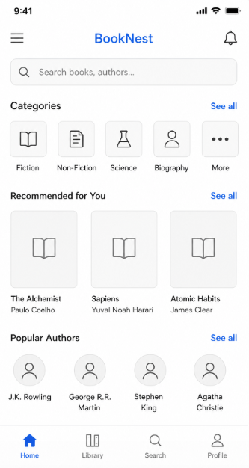
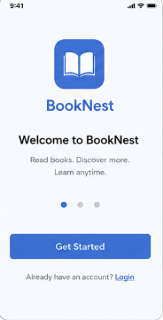

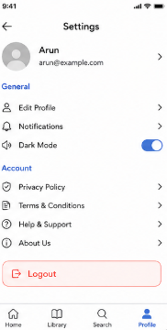
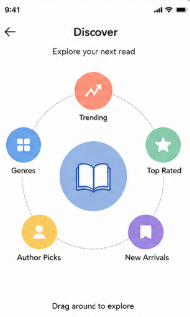

PROCEDURE:
Step 1: Planning the Prototype
- Identified navigation types:
  - Familiar: Menu bar, search bar, bottom navigation.
  - Unfamiliar: Gesture-based circular navigation.
- Sketched initial layout on paper.
Step 2: Creating Wireflow Project
- Opened Wireflow website.
- Created a new project.
- Selected blank template.
Step 3: Designing Screens
- Created multiple screens:
  - Onboarding Screen
  - Dashboard Screen
  - Discover Screen
  - Settings Screen
Step 4: Adding Navigation
- Added links between screens.
- Used arrows to show user flow.
Step 5: Usability Testing
- Shared prototype with users.
- Observed how users interact.
Step 6: Analysis
- Compared familiar vs unfamiliar navigation.
- Collected feedback.
SCREENS DESCRIPTION:
1. Onboarding Screen
- Displays app name and logo
- “Get Started” button
- Login option
2. Dashboard Screen (Familiar Navigation)
- Search bar
- Categories section
- Recommended books
- Bottom navigation bar
3. Discover Screen (Unfamiliar Navigation)
- Circular layout
- Gesture-based interaction
- Options like Trending, Genres, Top Rated
4. Settings Screen
- User profile details
- General settings
- Dark mode toggle
- Logout option

RESULT:
- The prototype was successfully created using Wireflow.
Familiar navigation (Dashboard, Settings) was easy to use and understand.
Unfamiliar navigation (Discover screen) was interactive but required more time to learn.
A combination of both provides a better user experience.

